Chapter 18, Solution 57.

W_{1Ω} = 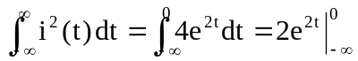 = 2 J or

I(ω) = 2/(1 – jω), |I(ω)|² = 4/(1 + ω²)

W_{1Ω} = 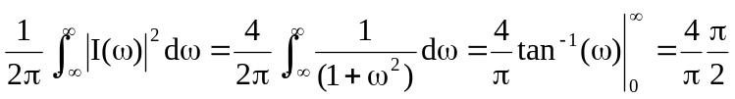 = 2 J

In the frequency range, –5 < ω < 5,

W = 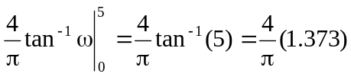 = 1.7487

W/ W_{1Ω} = 1.7487/2 = 0.8743 or

87.43%

